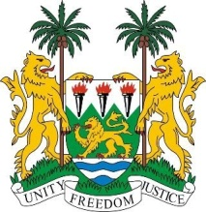
SIERRA LEONE
25th Session of the UPR

KINGDOM OF THAILAND

STATEMENT BY SIERRA LEONE

11 May 2016

Mr President,

Sierra Leone warmly welcomes the delegation of the Kingdom of Thailand and thanks them for their oral presentation.

Since the last UPR, Thailand has passed an impressive number of laws and drawn up policies and strategies that would go a long way in addressing the human rights of its peoples. My delegation applauds the consistent efforts to implement various policies and measures into national laws, including the 3rd National Action Plan and notes with satisfaction the progress made in the promotion of the economic and social rights, including the Universal Health Coverage Scheme and the National Plan for Older Persons.

Thailand has also issued a standing invitation to all special procedure mandate holders, has met all its reporting requirements to the Treaty Bodies and has consistently contributed to the OHCHR since 2013.

Recommendations:

- Ratify and accede to the ICRMW and ICPPED.
- Raise the age of criminal responsibility to 12 or above.
- Ensure that the minimum age of marriage is 18 for both boys and girls.
- Ratify ILO Convention 169 and 189.

Finally, Sierra Leone wishes the Kingdom of Thailand every success.

Thank you, Mr President.

